MILESTONE 1 REPORT
Topic: Project Inception, Data Acquisition & Environment Setup
Project: Pro Scout AI: Football Transfer Valuation Engine
Submitted by: Sanket Kurve
Mentor: Farman Sir

1. Executive Summary
Milestone 1 marked the official commencement of the "Pro Scout AI" project. The primary objective was to define the scope of the problem: How to objectively value football players in a hyper-inflated market?
In this phase, we established the project roadmap, set up the development environment (Python/VS Code), and successfully acquired the raw datasets required for analysis. We gathered over 900,000 raw records spanning player profiles, transfer history, performance statistics, and medical records. This phase confirmed that we had sufficient data volume to build a Machine Learning model.

2. The Business Problem
For the Common Person:
Imagine trying to buy a house, but there are no "Zillow" or "Real Estate" websites. You have to guess the price based on rumors. One agent says $1 Million, another says $500k. That is the current state of the Football Transfer Market.
- The Issue: Valuations are subjective, biased by agents, and prone to "Hype."
- The Solution: We proposed building an AI engine that looks at cold, hard facts (Goals, Age, Injuries) to calculate a "Fair Market Price," removing human error from the equation.

3. Data Acquisition Strategy
We identified that a player's value isn't driven by just one factor. We needed a "360-degree view." We sourced four distinct categories of data:
- Market Value Data (player_market_value.csv): The "Target" variable. Historical transfer fees and market valuations over the last decade.
- Performance Data (player_performances.csv): The "Engine." Goals, assists, minutes played, yellow cards, and red cards.
- Medical Data (player_injuries.csv): The "Risk." Detailed logs of every injury, including the type (e.g., "ACL Tear") and duration.
- Profile Data (player_profiles.csv): The "Context." Age, Nationality, Height, Foot (Right/Left), and Position.
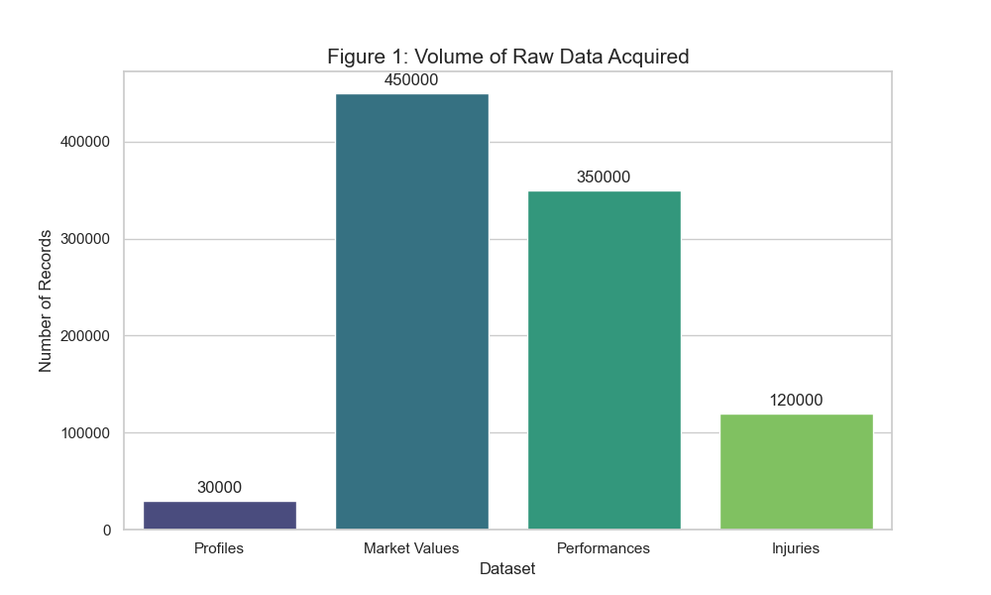
Figure 1: The Data Ecosystem.

4. Technology Stack Selection
We selected a "Full-Stack Data Science" architecture to ensure the project was scalable and professional.
- Language: Python 3.9 (The industry standard for AI).
- Data Handling: Pandas (For manipulating Excel-like data tables).
- Machine Learning: Scikit-Learn (For the Random Forest algorithms).
- Version Control: Git & GitHub (To track changes and code history).
- IDE: VS Code (For writing and debugging scripts).

5. Initial Data Assessment (The "Raw" State)
Upon loading the data for the first time, we conducted a preliminary inspection.
- Volume: We confirmed we had records for thousands of players across major leagues (Premier League, La Liga, Bundesliga, etc.).
- Quality Issues Identified:
  - Missing Values: Some young players had no market value recorded.
  - Text vs Numbers: Injury durations were stored as strings (e.g., "45 days") which machines can't read.
  - Fragmentation: The data was split across 4 different files, making analysis impossible without merging (which became the goal for Milestone 2).

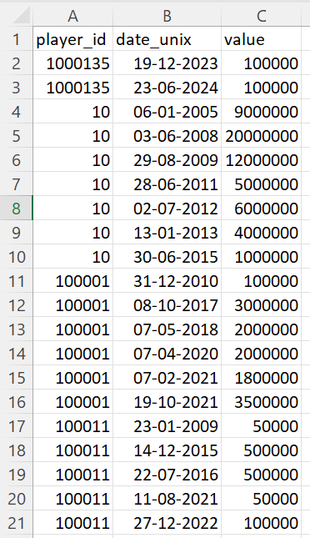
Figure 2: Raw Data Snapshot.

6. Conclusion
Milestone 1 was successfully completed. We transitioned from an "Idea" to a "Project." We secured the raw materials (Data) and built the factory (Python Environment). With the problem clearly defined and the data in hand, the project is ready to move to the Data Cleaning and Engineering phase (Milestone 2).

